**SHIMONI DEMONSTRATION SCHOOL- KIRA**

**MID TERM TW0 EXAMINATIONS, 2023**

**TOP CLASS NUMBERS**

**Name ____________________________________________________**

1. Fill in the missing numbers.

l, , 3, , , 6, 7,

l l, l 2, l 3, , , , l 7

1. Read and draw.

3 balls on the mat

l cat under the ball

1. Use empty or full

A B

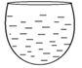 

Container ____________ is full

Container ________ is empty

1. Match correctly.

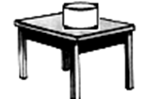 near

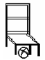 on

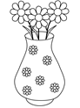 under

 in

1. Use taller or shorter.

**B**

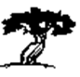 

**A**

Tree ________ is taller

Tree _______ is shorter.

1. Write the number words.

0 _______________ 2______________

5 _________________ l ________________

6_______________ 7________________

1. Write the next number

l _______ 9 __________

6______ l6 __________

1. Fill in the missing number words.

one _________ three __________ five ____________

seven ____________ nine ______________

1. Name these shapes.

|  |  |  |  |
| --- | --- | --- | --- |
|  |  |  |  |
|  |  |  |  |

**(oval, square, zig zag, cone, triangle)**

1. Draw balls for the number.

7=

3= 4=

1. Count and write in words.

=_________________________ =___________________

=______________________________

=________________________

( **zero, six , four, five)**